**SCRUM EVENTS**

SPRINT PLANNING:

Sprint planning is an event in scrum that kicks off the sprint. The purpose of sprint planning is to define what can be delivered in the sprint and how that work will be achieved. Sprint planning is done in collaboration with the whole scrum team.

What Happens in Sprint Planning?

During sprint planning, the entire Scrum team collaborates and discusses the desired high-priority work for the sprint and defines the sprint goal. The Scrum Master’s role is primarily to facilitate the meeting. The Product Owner describes the objective of the sprint and also answers questions from the development team about execution and acceptance criteria/criteria of satisfaction.  The development team has the final say in how much of the high-priority work it can accomplish during the sprint.

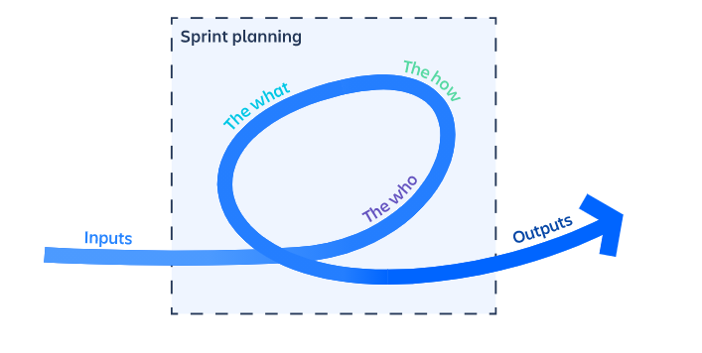

**Test case:**

|  |  |  |  |
| --- | --- | --- | --- |
| **As a** | **I want to** | **So that** | **Sprint no.** |
| **administrator** | Add a robotic categories of toys | to increase the products | **1** |
| **administrator** | See the sales for particular month | to know the productivity | **1** |

* **The What** –  The product owner describes the objective(or goal) of the sprint and what backlog items contribute to that goal. The scrum team decides what can be done in the coming sprint and what they will do during the sprint to make that happen.
* **The How** – The development team plans the work necessary to deliver the sprint goal. Ultimately, the resulting sprint plan is a negotiation between the development team and product owner based on value and effort.
* **The Who** – The product owner defines the goal based on the value that they seek. The development team needs to understand how they can or cannot deliver that goal. If either is missing from this event it makes planning the sprint almost impossible.

**Sprint Stand Up Meeting :**

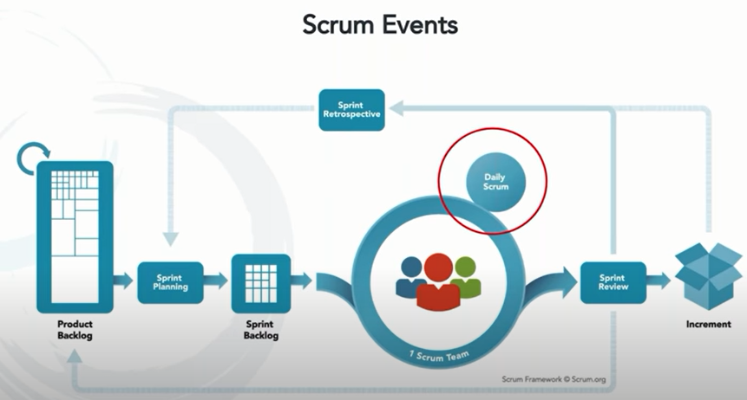

It is conducted by the scrum master at same place same time everyday

The meet will be no longer than 15 mins

Agenda is to know about the flow of work, any blockers to be resolved and list those

Discussion about task done yesterday and what they going to do now

**Sprint Review:**

* Sprint review is the operation which happens for the increment feature of the product.
* Review should be conducted on the incremented feature of the product.
* It is the review inclusive of developers and stakeholders feedback. So that we should sure about we delivered what is required for product.
* Participants in the sprint review typically include the product owner, the Scrum team and the Scrum master.
* During the sprint review, the project is assessed against the sprint goal determined during the sprint planning meeting.

**Explaining the Sprint Review with the test case:**

* If the customer wants the payment confirmation message through the E-mail.
* So the developing team should add a feature which satisfies the customer need.
* So review meeting is held to discuss that this is what actually customer wants. And a time line is given for that work and again review meeting should be called regarding added feature.
* After adding this new feature the scrum team cannot release it in the market without the review of the product owner or the Scrum master.
* So the Scrum team should review the new added feature with the Scrum master and product owner.
* After Sprint review only the feature is permitted to increment in the product.

**Template of the Sprint Review:**

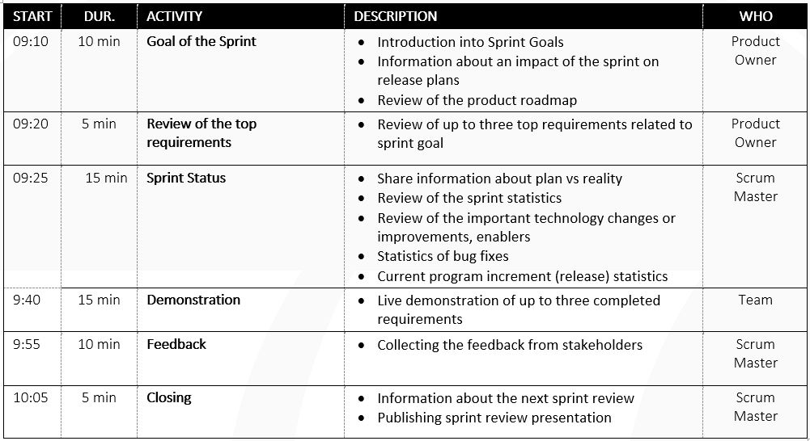

***SPRINT RETROSPECTIVE***

The sprint retrospective is **a recurring meeting held at the end of a sprint used to discuss what went well during the previous sprint cycle** and what can be improved for the next sprint. The Agile sprint retrospective is an essential part of the Scrum framework for developing, delivering, and managing complex projects.

The main purpose of the Sprint Retrospective is to plan ways to increase quality and effectiveness.

During the Sprint Retrospective, the team discusses:

* What went well in the Sprint
* What could be improved
* What will we commit to improve in the next Sprint

The Scrum Team inspects how the last Sprint went with regards to individuals, interactions, processes, tools, and their Definition of Done. Inspected elements often vary with the domain of work. Assumptions that led them astray are identified and their origins explored. The Scrum Team discusses what went well during the Sprint, what problems it encountered, and how those problems were (or were not) solved.

During each Sprint Retrospective, the Scrum Team plans ways to increase product quality by improving work processes or adapting the definition of “Done” if appropriate and not in conflict with product or organizational standards.

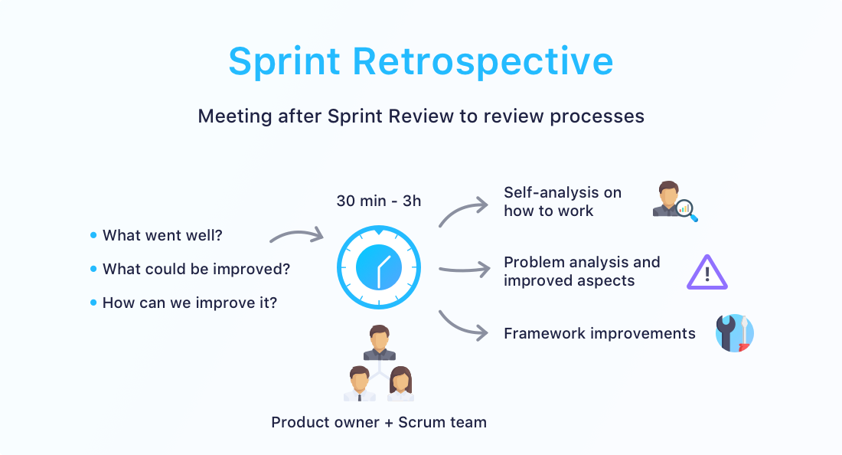

**Swimlanes:**

Swimlanes purposes and benefits

In today’s organizations with multiple work groups or departments, this diagramming can help in various ways:

1.It can help to ensure that the right hand knows what the left is doing in an organization. Swimlane Diagrams, and swimlanes used in other diagram types, highlight which process steps or sub-processes are assigned to a particular actor in the organization.

2.By spelling this out in a diagram, you can highlight redundancies between different lanes and identify bottlenecks, waste and other inefficiencies. This sometimes reveals duplicative or unnecessary steps in a process, such as different departments performing the same task. It also can highlight process delays or capacity constraints within a particular swimlane so that they can be addressed and resolved. This can increase performance and quality and reduce unnecessary work and costs.

3.You can use a second Swimlane Diagram to model a better way to structure the process or to account for changing circumstances, such as staffing changes or technology changes.

4.Like other diagrams, Swimlane Diagrams can communicate in clearer terms than a narrative description would.

5.Swimlane Diagrams can be formalized as a way to integrate processes between teams or departments, resulting in cleaner processes on an ongoing basis.

